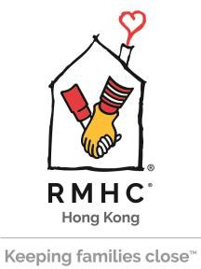

物資捐贈表格 In-Kind Donation Form
捐贈/捐款者資料 Donor’s information
捐款人 / 公司 / 團體名稱 先生/女士/小姐
Donor / Company / Organization Name Mr./ Ms./Miss
聯絡人 (如適用) 先生/女士/小姐 職位
Contact Person (if applicable) Mr./ Ms./Miss Title
地址 (以發出捐款收據)
Address (for issuing donation receipt)
電郵 電話 日期
Email Tel. Date
如收據或感謝信抬頭與上述公司/個人名稱不同，請註明:
If the donor’s name in the donation receipt or thank you letter is different from the above, please state:

所捐贈物資 Item to be donated
直接捐贈物資，請見以下列表。Please refer to the below table for item(s) to be donated.
我願意捐出港幤 ，作購買指定物資 (見以下列表)，供麥當勞叔叔之家慈善基金有限公司提供服務使用。
如有餘款，將撥捐麥當勞叔叔之家慈善基金有限公司作支持日常運作。
I would like to donate HK$ for purchase of items (Please refer to the details listed in the below table) to RMHC Hong
Kong. If there is surplus amount after purchasing the items, it will be donated to RMHC Hong Kong for general use.

捐款現金港幣$100或以上可申請扣稅。Cash donations of HK$100 or above are tax deductible.
直接捐贈物資將不會獲發收據。No donation receipt would be issued for making in-kind donation directly
為節省行政開支，我不需要捐款收據。To save administration costs, no donation receipt is required

項目 Items | 數量 QTY | 物品等值 (港幣)  Total Market Value (HK$)

捐款方法 Donation Method
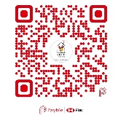
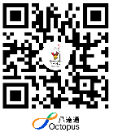
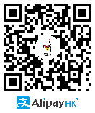
- 支付寶香港 電子錢包 八達通 PayMe 現金 Cash
AlipayHK electronic Octopus
wallet

請保留支付寶香港/八達通/PaymMe之確認捐款記錄，並電郵或傳真至2947 8780。
Please keep AlipayHK/Octopus/PayMe confirmation payment records and send to us by email or by fax to 2947 8780.

- 直接存款或轉賬至「麥當勞叔叔之家慈善基金有限公司」銀行戶口
Direct deposit/transfer to the Ronald McDonald House Charities Hong Kong Limited
渣打銀行Standard Chartered Bank 447-1-060619-5 / 匯豐銀行HSBC 067-450999-292

- 劃線支票 (抬頭請寫 「麥當勞叔叔之家」或「麥當勞叔叔之家慈善基金有限公司」)
Cheque payable to “RMHCHK” or “Ronald McDonald House Charities H.K. Ltd.”
信用卡 Credit Card
○VISA ○ 萬事達咭Master Card ○ 美國運通American Express
信用卡號碼 有效日期至
Credit Card No. Expiry Date
持卡人姓名 持卡人簽署
Cardholder’s Name Cardholder’s Signature

注意事項 : 所收集的個人資料將保密處理，作為寄發收據及通訊之用。如不欲收取本機構資訊／需查詢／更改個人資料，請與我們聯絡(電話：2947 8778 ; 傳真：2947 8780 電郵：rmh@rmhc.org.hk )
Note: The personal data collected will be treated as strictly confidential and will be used only for receipting and other communications with you. If you do not wish to receive any mailings from us, or if you want to have access to or change your personal data, please contact us (Tel: 2947 8778 Fax: 2947 8780
Email: rmh@rmhc.org.hk).

香港麥當勞叔叔之家慈善基金 Ronald McDonald House Charities Hong Kong
香港觀塘有信街2號 2 Yau Shun Street, Kwun Tong, Hong Kong
電話Tel: (852) 2947 8778 傳真Fax: (852) 2947 8780 電郵Email: rmh@rmhc.org.hk 網址Website: www.rmhc.org.hk
只供內部職員使用 For internal use only
收貨/收款日期Date received : | 收貨/收款人姓名 Received By (Staff Name) :

