Organizer Beneficiary Support Organization
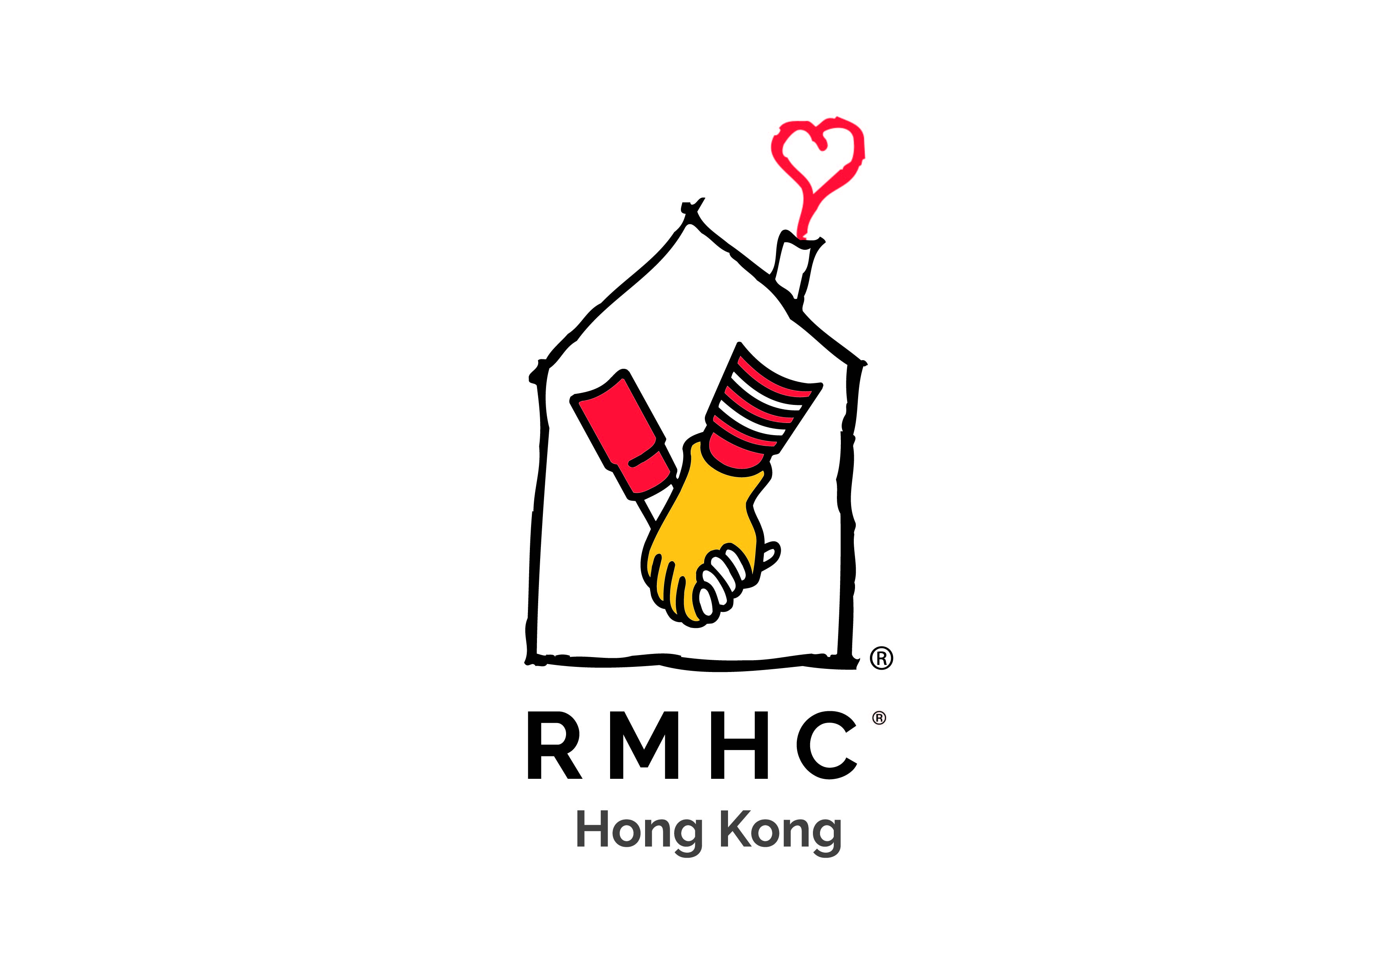
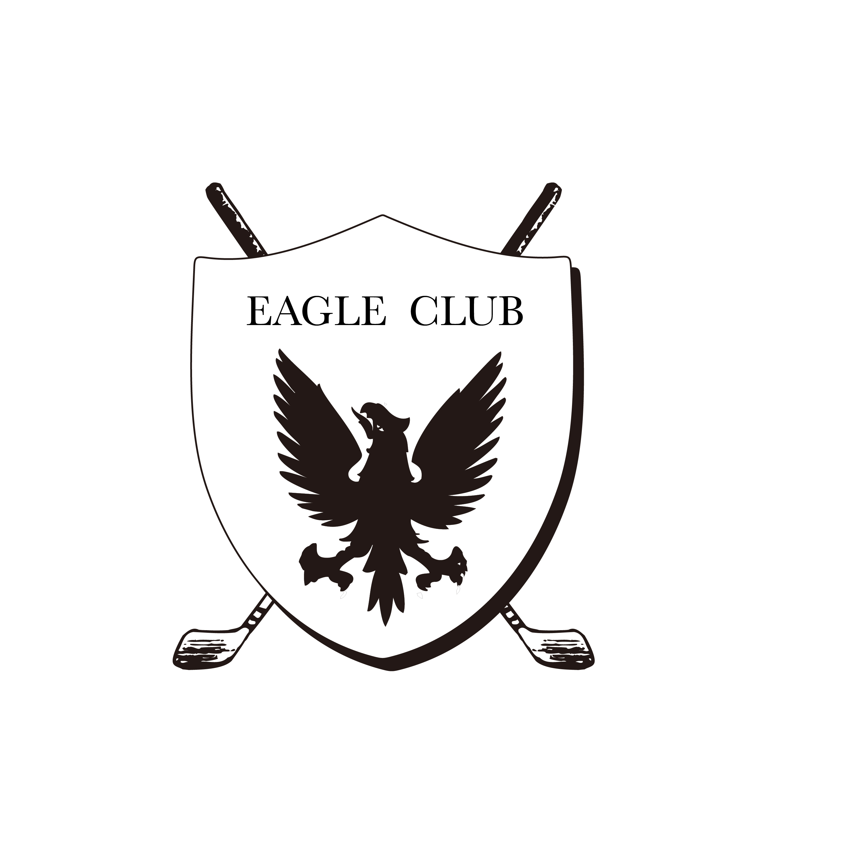
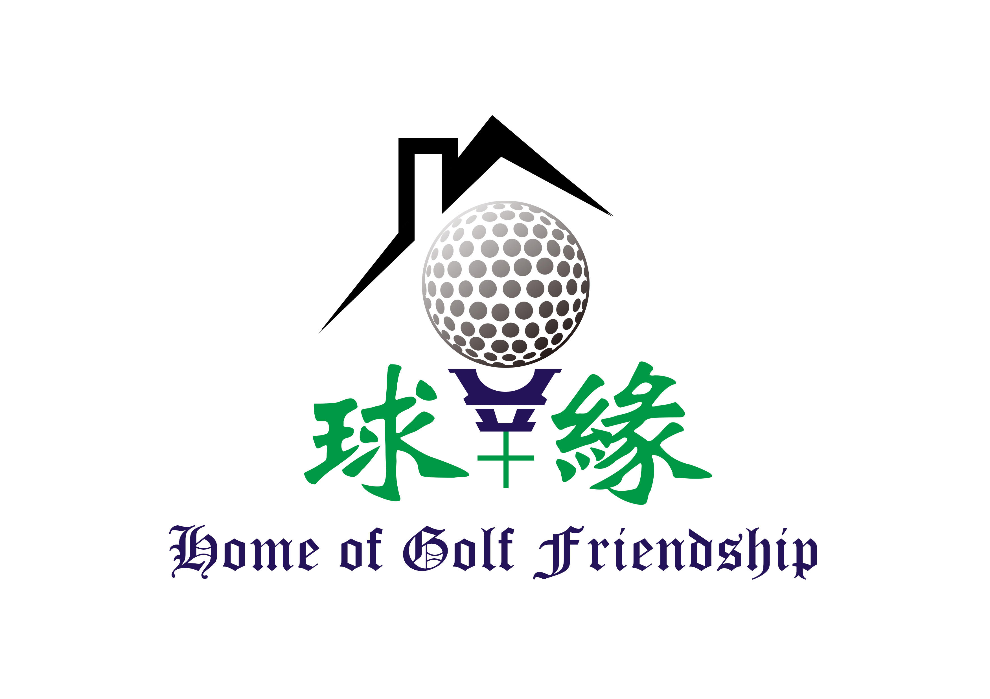

Dear Friends of RMHC,

We are pleased to announce that the Ronald McDonald House Charities® Hong Kong Golf Tournament 2019 will take place at the Golf Club, Fanling on May 31, 2019, and it would be our honored for you to join us for this important event.

In order to expand our services and reach out to more families in Hong Kong, RMHC Hong Kong relies on the generous support and sponsorship of the many companies to raise funds through this event. This event is one of the three big annual fundraisers, alongside the Raffle Ticket Sale and the Gala Dinner, and your presence would certainly help garner support. All funds raised from the tournament will go towards the Ronald McDonald House® serving families here in Hong Kong

Since we established Asia’s first RMH program in 1996, we have provided more than 150,000 nights of accommodation for sick children and families in Hong Kong. We are privileged to provide a place of solace when most needed, a residential family-centered care for the sick children with their parents as well as siblings, which is unique in Hong Kong. This kind of service would not be possible without the generous support from donors like you for which we are extremely grateful.

We count on your continuous support to make this Golf Tournament a success. Please find the enrollment form attached and kindly reply before April 25, 2019. Should you have any questions please do not hesitate to contact Ms. Cherry Law, our Fundraising Manager, Event at (852) 2947-8778.

Yours Sincerely,
Iris Wong
Executive Director
Ronald McDonald House Charities Hong Kong

